### Use the below table for the following Questions.

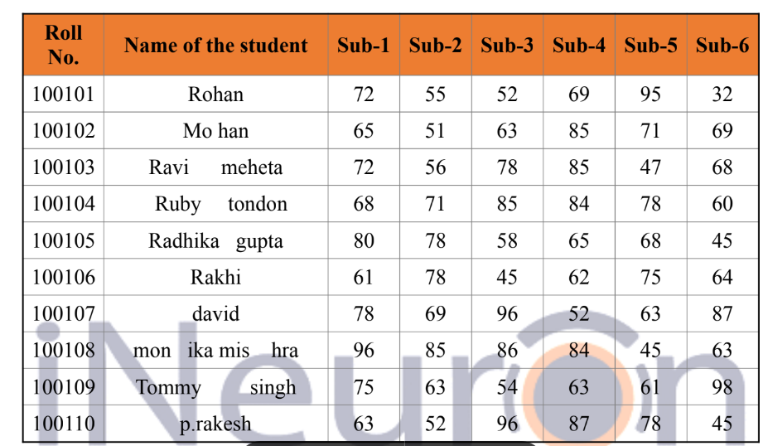

### 1. Find the Minimum Marks and Maximum marks scored by each student.

#### Ans:

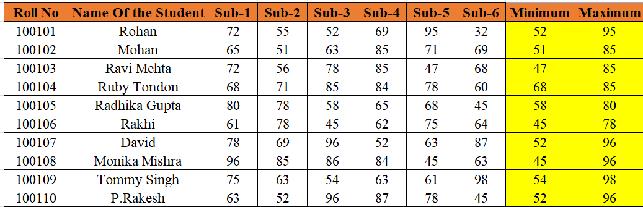

### 2. Calculate the totals for each student, use conditional formatting to highlight the top students who have scored more than 480.

#### Ans:

As per given data no student scored 480

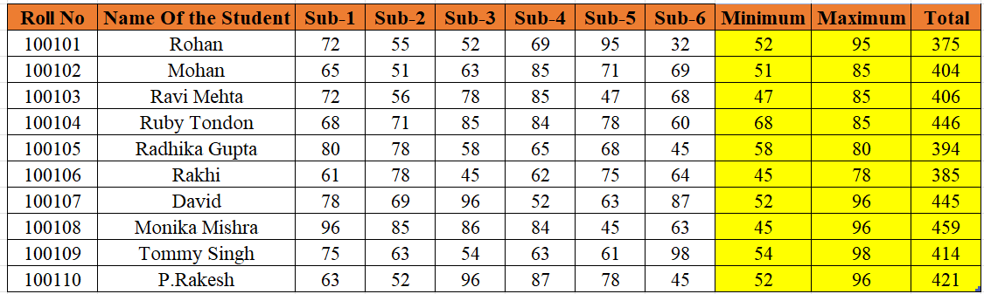

### 3. Calculate the length of the names of each student.

#### Ans:

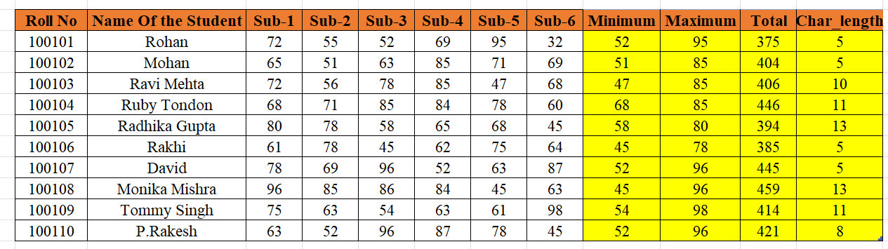

### 4. Replace the Name Rakhi with Rocky. Use Formulas

#### Ans:

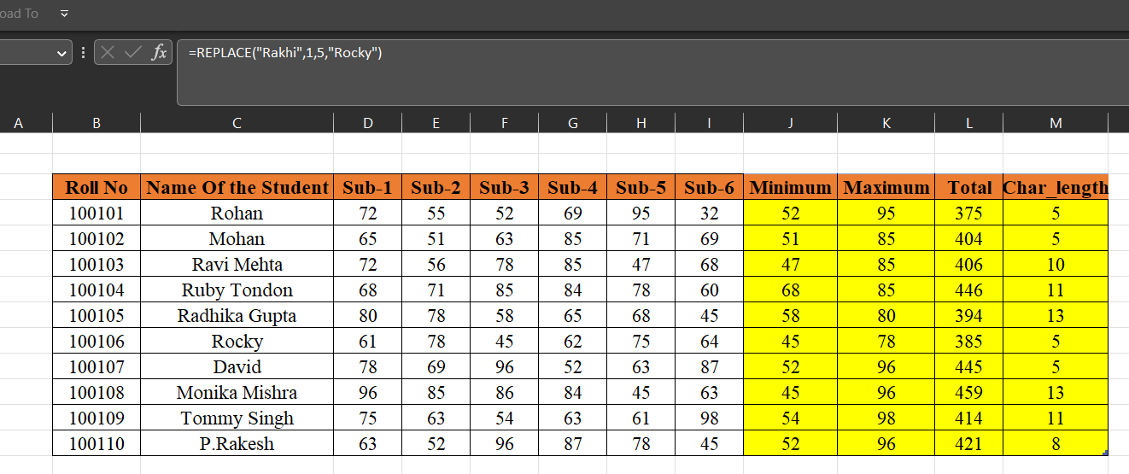

### 5. Combine the Roll Numbers and Names. Use formulas. The end result should look like below.

### 100101Rohan

#### Ans:

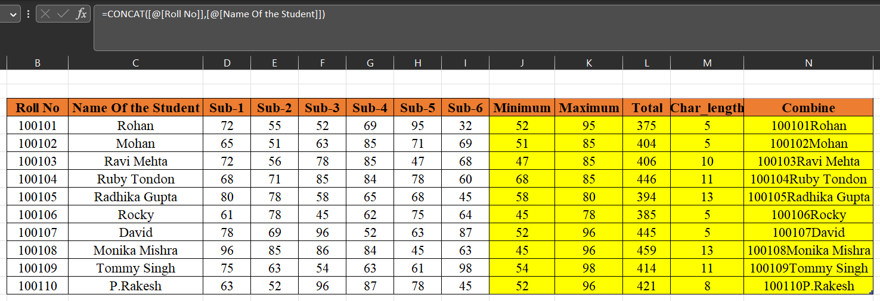

### 6. As you can see that some names have spacing issues. Use Formulasto correct that spacing. Also ensure that the names and surnames start with a capital letter

#### Ans:

